**Use cases of Geo-redundant back and restore.**

|  |  |  |  |  |
| --- | --- | --- | --- | --- |
| Scenario | Using Azure Portal | Using Terraform | Same Region | Paired Region |
| Vanilla setup of flex server for Backup & restore | Worked | Worked | worked | Worked |
| Enabled CMK, Vnet Subnets of flex server for Backup | Worked | Worked | Worked | - |
| Enabled CMK, Vnet Subnets of flex server for Restore | Worked. | Worked | Worked | Did not work using azure portal and Terraform. |

**Enable the diagnostics settings and sending the events to the Eventhub.**

|  |  |  |  |
| --- | --- | --- | --- |
| Scenario | Using Azure Portal | Using Terraform | Same Region |
| Enabled EventHub and Diagnostics settings to capture primary postgreflex server metrics | Worked | worked | worked |
| Performing PointInTime Restore in the same region | Lost the diagnostics settings | Lost the diagnostics settings | - |

List of automated backups which are available in the primary server.

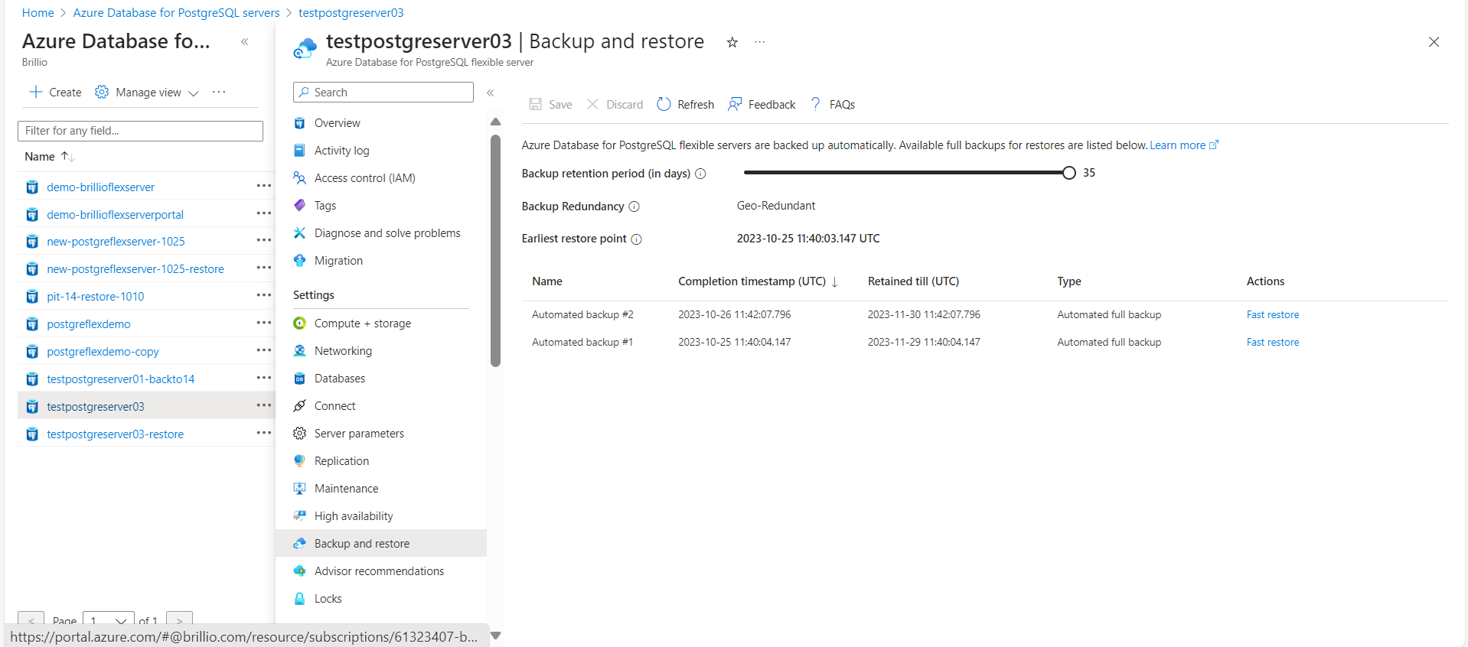

When we are trying to restore to a paired region, we are getting the below error.

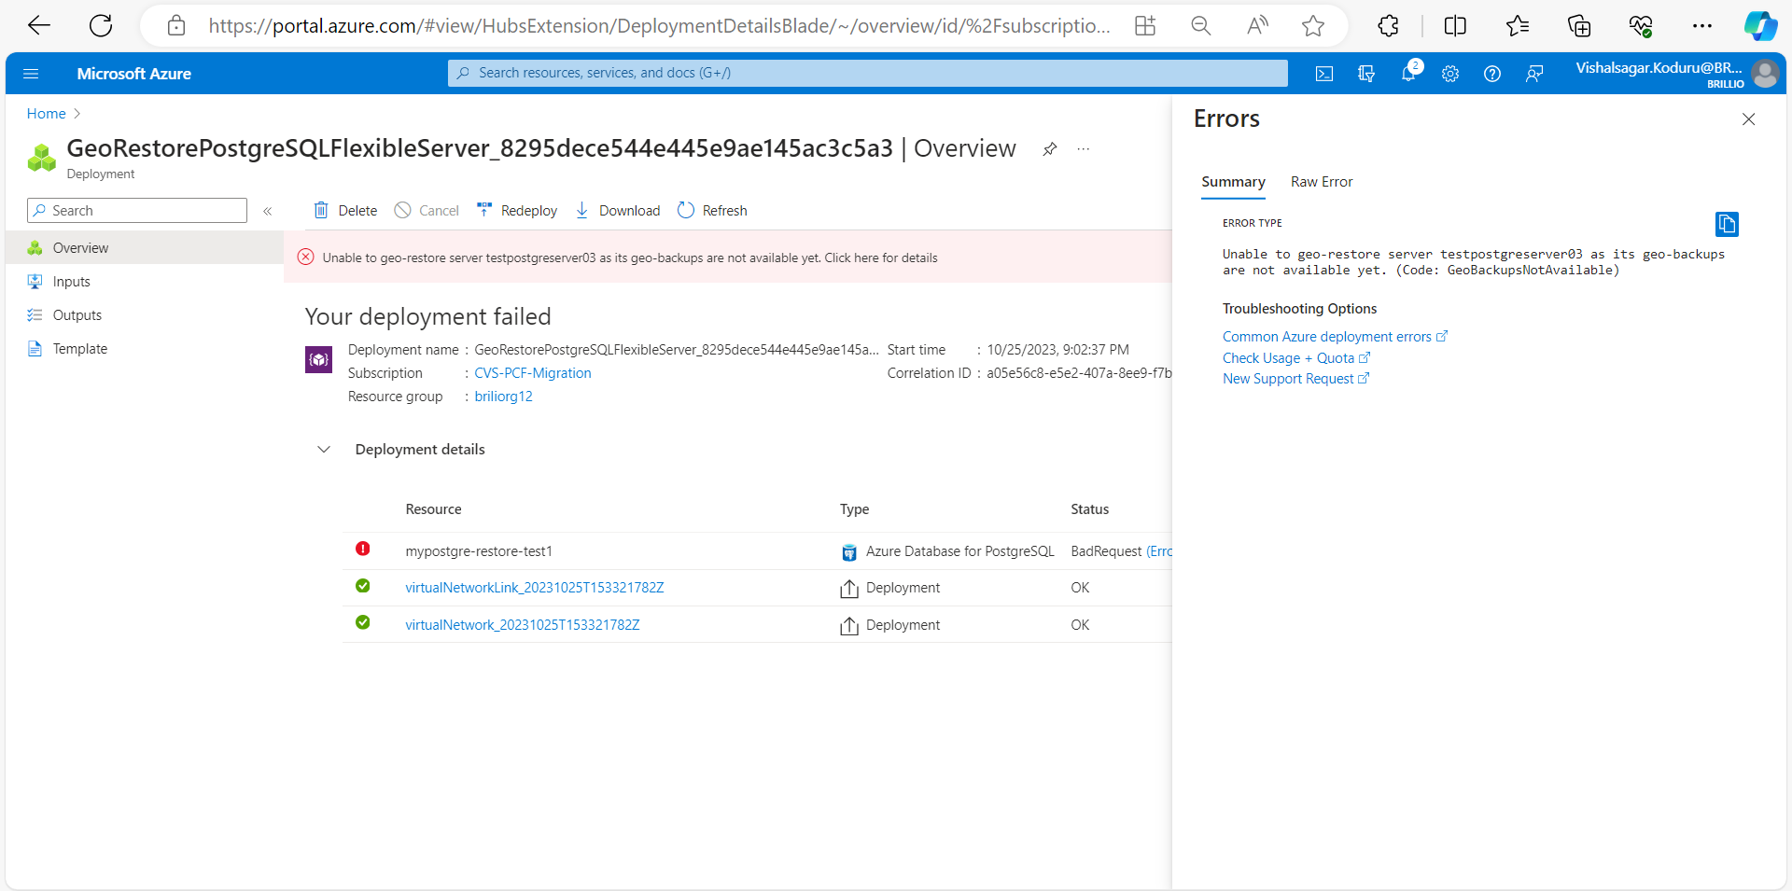

The same error while trying to restore using Terraform scripts.

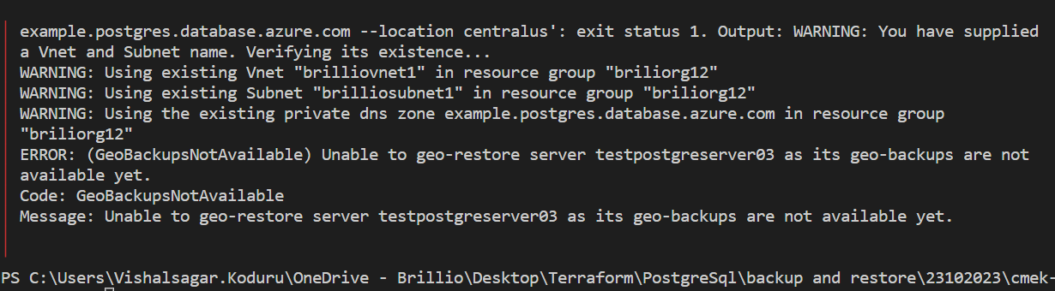

In the Primary server through diagnostics settings, we have configured EventHub.

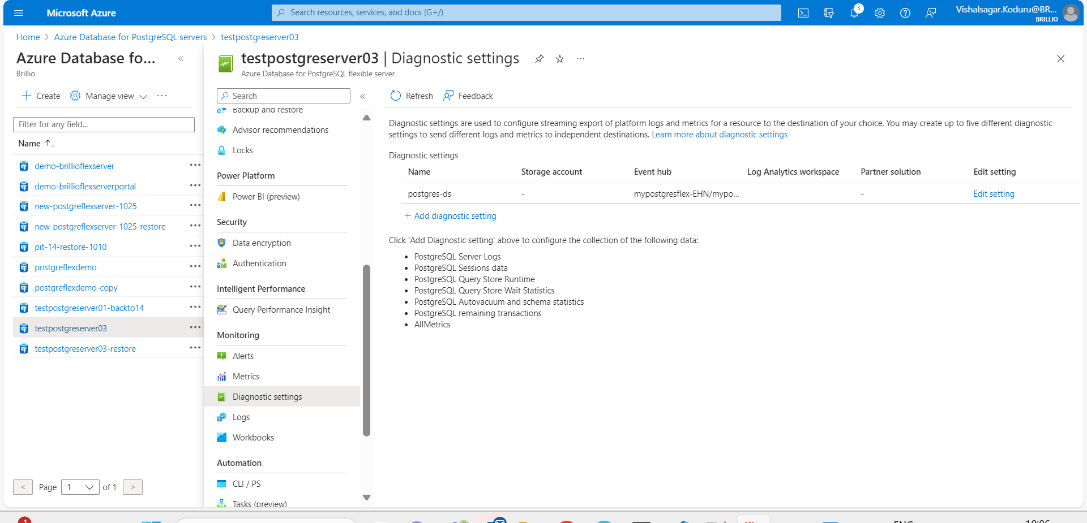

When we Restore the Primary server, We can’t see the diagnostics in the Secondary server.

